Pishing Detection & Awareness Report
A security analysis of phishing email samples with risk classification and user awareness recommendations
Angel Ngwenya
Future interns-Cybersecurity internship: 21/05/2026
Contents
Confidentiality Statement 2
Disclaimer 2
Introduction 3
Email Analysis 4
Sample 1: PayPal Account limitation email 4
Sample 2: Wire Transfer Scam (Business email compromise) 5
Sample 3: LastPass Security Alert 6
Sample 4: Marketing Email(Non-phishing example) 7
Prevention Guidelines 8
Conclusion 9

Confidentiality Statement
This report is prepared for educational and internship assessment purposes only. All email samples used in this document are publicly available examples or simulated phishing scenarios and do not contain real sensitive organizational data.
Any resemblance to real individuals or organizations is purely coincidental. The contents of this report should not be used for malicious purposes.

Disclaimer
The information provided in this report is intended solely for cybersecurity awareness and educational purposes. The analysis reflects general phishing detection practices and may not cover all possible threat scenarios.
Users are advised to follow organizational security policies and consult professional cybersecurity experts when handling real threats.

Introduction
Phishing is one of the most common forms of cybercrime today, where attackers pretend to be trusted organizations or individuals in order to steal sensitive information such as passwords, banking details, or verification codes. Instead of exploiting technical flaws, these attacks mainly target human emotions and behavior, often using fear, urgency, or curiosity to manipulate victims into responding. Because of this, user awareness and caution play a major role in preventing phishing attacks. This report examines several phishing email samples, highlights the warning signs commonly found in such messages, evaluates the risks they pose, and suggests practical strategies that users can apply to protect themselves online.

Email Analysis

Sample 1: PayPal Account limitation email
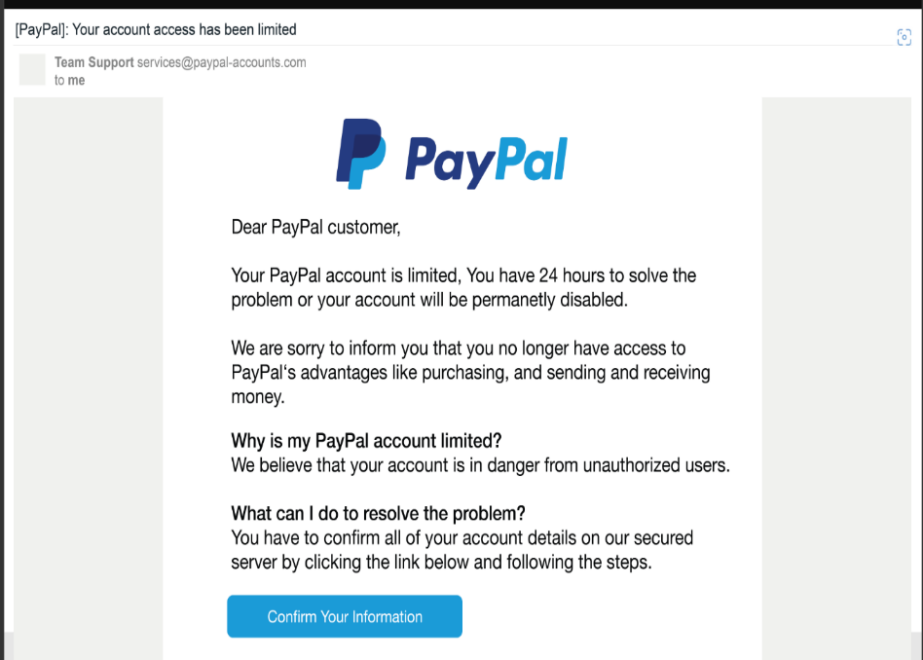
Figure 1: example1- paypal phishing email
An email claims the user's PayPal account has been limited and requires immediate verification.
Pishing Indicators:
- Fake sender domain (paypal-accounts.com instead of paypal.com)
- Generic greeting (“Dear PayPal customer”)
- Urgent deadline (24 hours)
- Threat of account suspension
- Suspicious “Confirm Your Information” button

Risk Classification:
- Phishing – High risk.
The email creates urgency to pressure the user into clicking a malicious link. The link likely leads to a fake website designed to steal login credentials.

Sample 2: Wire Transfer Scam (Business email compromise)
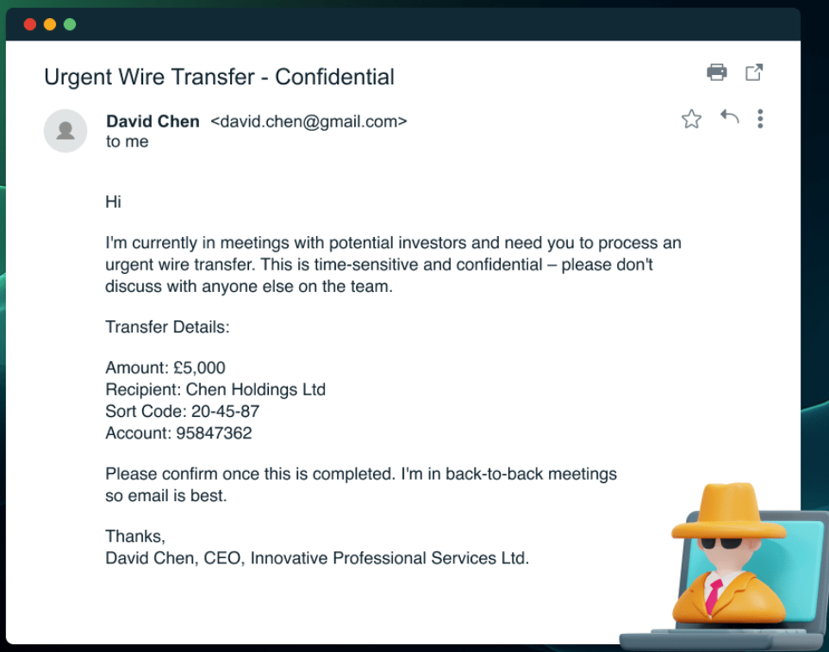
Figure 2: example2 - wire transfer
An email claims to be from a CEO requesting an urgent wire transfer.
Indicators:
- Sender uses personal Gmail address
- Impersonation of a company executive
- Urgent and confidential request
- Instruction to avoid verification
- Request for financial transaction (£5,000)
Risk Classification:
- Phishing – High risk.
This is a Business Email Compromise (BEC) attack where the attacker impersonates leadership to trick employees into transferring money.

Sample 3: LastPass Security Alert
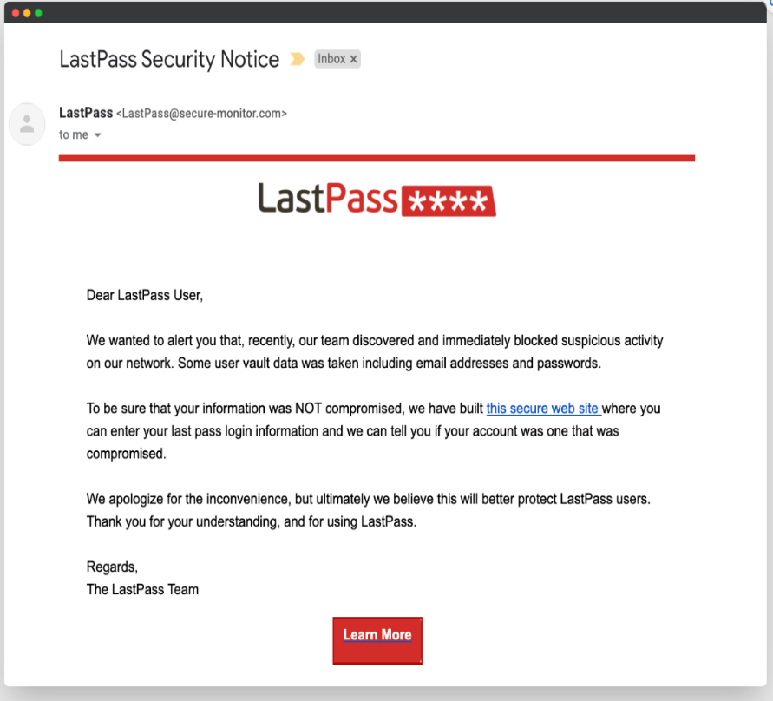
Figure 3: example3 - LastPass security alert
Email claims security breach and asks users to verify account information.
Indicators:
- Suspicious sender domain (secure-monitor.com)
- Scare tactic (data breach warning)
- Request for login information
- Suspicious “secure web site” link
- Generic greeting
Risk Classification:
- Phishing – High risk
The attacker uses fear of a breach to trick users into entering credentials on a fake website.

Sample 4: Marketing Email(Non-phishing example)
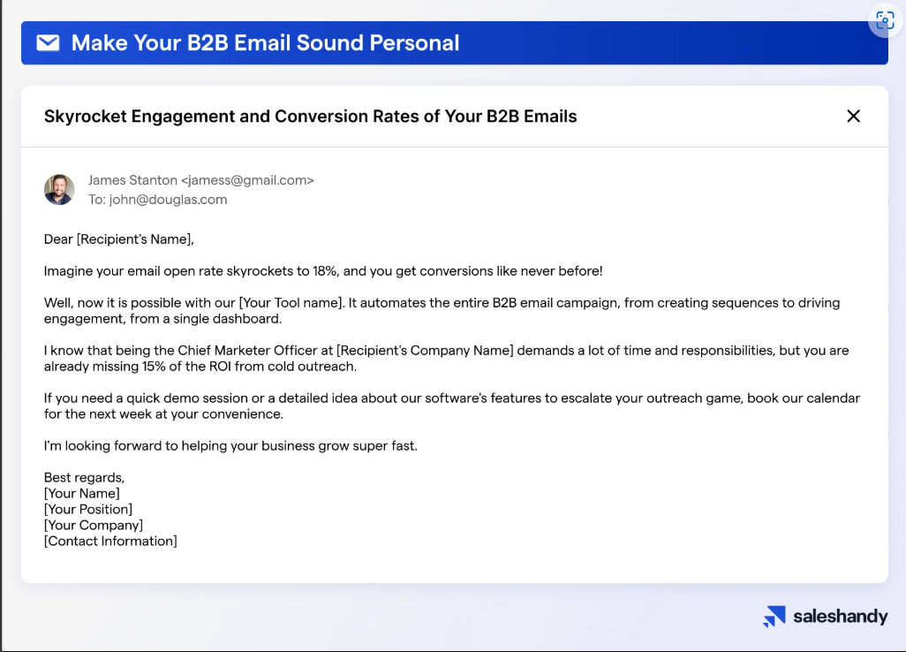
Figure 4: example4 - non-phishing email example
This email promotes a business tool designed to improve email engagement and conversion rates.
Indicators of Non-Phishing:
- No urgency or threats
- No request for sensitive information
- Clear business purpose (marketing/demo offer)
- No impersonation of a trusted organization
- No malicious attachments
Risk Classification:
- Non-Phishing
This email is not a phishing attack but rather a generic marketing message. While it is not harmful, it lacks personalization and uses a non-official email domain, which may reduce trust.

Prevention Guidelines
- Verify sender email addresses carefully
- Avoid clicking unknown links
- Never share passwords or OTPs via email
- Use Multi-Factor Authentication (MFA)
- Contact organizations through official channels

Conclusion
Phishing attacks remain one of the most widespread threats in cybersecurity today. As shown in this report, these attacks usually succeed not because of advanced technology, but because they manipulate people through urgency, fear, and impersonation. Attackers often disguise themselves as trusted individuals or organizations to deceive users into sharing sensitive information. This highlights the importance of user awareness and careful online behaviour, which continue to be the strongest defenses against phishing attacks.

